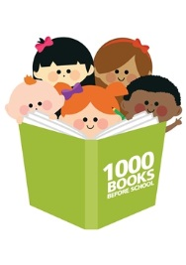
- How old does my child have to be to start the program?

Your child can start at any time as long as they have not started school. The earlier you start, the longer you have to complete the program.

- What happens if I have more than one child?

You register each child! There is no limit to how many family members can participate.

- I want all my children to participate. Do they each need a library card?

Only one card is needed to register. You can join up each child as member if you wish, but it is not necessary.

- Can I count books I read to my child before I registered?

No - the program begins for your family on the day you register, and you only count books you read the day you register.

- My child likes to read the same book over and over again. How do I count that?

Repetition is important for learning. You mark or colour in a circle in your reading record every time you read a book. If you read the same book 10 times, you mark or colour in 10 circles.

- Can I count books that are read to my child by others or at programs like Storytime?

Every book that your child completes, or actively listens to, counts – this includes stories read at Storytime sessions, day care, playgroup and kindergarten, as well as reading the same book over again. You can read books from anywhere – not just library books.

- Do the books have to be library books?

No, any book that is read counts, whether it’s a library book, your own book, your friend’s book, etc.

- What if my child starts school and hasn’t finished the program?

You have until the end of term 1 of the year your child starts school to finish your reading.

