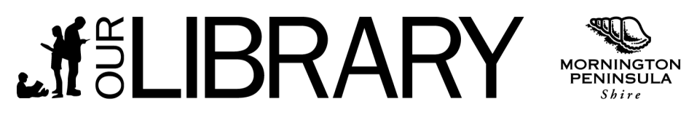

Fees and charges
- These fees and charges are applicable from 1 August 2015
- The following list of fees and charges is supported by Mornington Peninsula Shire Council
- All charges are non-refundable
- Unless specified (*) all charges include GST, where applicable
- It should be noted some values are different for borrowers with C (Concession) Borrower Type
- These concessions are outlined below

Service | Standard rate | Concession rate
Printing and Photocopying (per page)
A4 page: black and white | $0.20 | $0.20
A3 page: black and white | $0.30 | $0.30
A4 page: colour | $1.00 | $1.00
A3 page: colour | $2.00 | $2.00
Overdue Charges *
Per item per day | $0.30 | $0.30
Maximum per item | $10.00 | $10.00
No overdue charges apply to Junior items*
Reservations | FREE | FREE
New Item Requests (per item) | $2.20 | $1.10
Inter-library loans from other libraries (per item)  Plus any additional costs incurred from the lending library | $2.20 | $1.10
Replacement Membership cards | $2.00 | $2.00
Lost or irreparable library items | Cost of the item | Cost of the item
Damaged repairable library items
Talking books: replacement cost of each disc | $22.00 | $22.00
All other library items | $6.00 | $6.00
Library Bags | $2.50 | $2.50
USBs | $5.00 | $5.00
Playaway Accessories
Batteries | $1.00 | $1.00
Headphones | $2.00 | $2.00

